A Project Report for
CSA-321 Project
Credits: 4
Submitted in partial fulfilment of
Bachelor of Computer Applications
by
SAIESHWAR MALKARNEKAR
MEVIN QUADROS
DIAS CHRIS FRANCO
SAHEEL SHAIKH
YASH SATISH BHANDARI
Under the Mentorship of
ASST. PROF. ANKITA FAL DESSAI
Department of Computer Applications

Rosary College of Commerce and Arts
Place: Navelim, Salcete-Goa
Date: January 2026

Examined by: Seal of the college:

PRELIMINARY PAGES
DECLARATION BY STUDENTS
We hereby declare that the details presented in this project report entitled "Smart Crowd Detection and Management System" is based on the project work carried out by us in the Department of Computer Applications, Rosary College of Commerce and Arts, Navelim-Goa, under the guidance of Asst Prof. Sanskruti Wadekar and the same has not been submitted elsewhere for the award of a degree or diploma by us. Further, we understand that Goa University or its authorities/college will not be responsible for the correctness of observations/experimental findings or other findings presented in this Project Report.
We hereby authorize the University/College authorities to upload this Project Report to the concerned repository or anywhere else as per the UGC regulations and make it available to anyone as needed.

Name of Student | Roll No. | Signature
Mevin Quadros | 2305122
Saieshwar Malkarnekar | 2305132
Chris Franco | 2305109
Yash Satish Bhandari | 2305142
Saheel Shaikh | 2305131

Date: April 2026
Place: Navelim-Goa

i
CERTIFICATE
This is to certify that the project entitled “Smart Crowd Detection and Management System” is a bona fide work carried out by Mevin Quadros, Saieshwar Malkarnekar, Chris Franco, Yash Satish Bhandari, and Saheel Shaikh under my guidance and supervision in partial fulfillment of the requirements for the award of the degree of Bachelor of Computer Applications.
This work has not been submitted previously for the award of any degree or diploma in this or any other university.

Asst. Prof. Anikita Fal Dessai
Project Guide
Department of Computer Applications

Asst. Prof. Mildred Lemos
BCA Program Coordinator
External Examiner
Date: April 2026

ii
ACKNOWLEDGEMENT
We take this opportunity to express our sincere gratitude to all those who supported us in completing this project.
We are deeply indebted to our project guide, Asst. Prof. Anikita Fal Dessai, Department of Computer Applications, for her invaluable guidance, constant encouragement, and constructive feedback throughout this project. Her expertise and patience were instrumental in shaping our ideas and bringing this project to completion.
We extend our sincere thanks to Asst. Prof. Mildred Lemos, BCA Program Coordinator, for providing the necessary facilities and institutional support.
We are grateful to the Principal of Rosary College of Commerce and Arts for providing a conducive academic environment to pursue our studies.
We also thank all faculty members of the Department of Computer Applications for their encouragement and support.
Finally, we thank our families and friends for their unwavering support and motivation throughout this journey.

iii
ABSTRACT
Crowd crushes and stampedes are tragic yet preventable incidents. The tragedy during the RCB celebration at M. Chinnaswamy Stadium highlighted the consequences of inadequate crowd monitoring.
CrowdSense is designed to address this issue through an AI-powered, real-time surveillance system. The system uses a Raspberry Pi 5 integrated with a camera module to run two AI models: YOLOv11n for crowd counting and density estimation, and YOLOv8 Pose for fall detection.
When abnormal conditions such as overcrowding or falls are detected, the system instantly alerts security personnel through a Flutter-based mobile application. Alerts include geolocation data via Google Maps and automated voice calls using Twilio.
The solution is real-time, cost-effective, scalable, and suitable for deployment in public venues such as stadiums, railway stations, malls, and festivals.

KEYWORDS
Crowd Safety, AI Surveillance, YOLOv11n, YOLOv8 Pose, Fall Detection, Raspberry Pi 5, Flutter, Firebase, Twilio, Real-Time Alerts, Edge Computing, Computer Vision

iv
CONTENTS
- Introduction 1-3
1.1 Background -> Information about Project
1.2 Aim and objectives
1.3 Research questions
1.4 Scope of the project
- Literature Review 4.5
2.1 Existing Systems
2.2 Traditional Surveillance Limitations
2.3 AI-Based Solutions
2.4 Edge Computing Approaches
2.5 Alert Mechanisms
2.6 Mobile Development Frameworks
2.7 Research Gap3
- Methodology 6-14
3.1 System Design
3.1.1 Use Case Diagram
3.1.2 ER Diagram / Flow Chart Diagram
3.1.3 Sequence Diagram
3.2 Implementations
3.2.1 S/W Tools
3.2.2 H/ W Tools
- Analysis and Conclusions 15-24
4.1 Testing
4.2 Future Enhancements
4.3 Conclusions

v
LIST OF TABLES
Table No. Description Page No.
3.1 Hardware Component Specifications and Justification 21
3.2 Integrated Software Stack and API Dependencies 23
3.3 System Operational Workflow and Data Pipeline 26
4.1 Performance Evaluation and Detection Accuracy Results 38
A.1 Project Cost Breakdown 49
________________________________________
LIST OF FIGURES
Figure No. Description Page No.
1.1 CrowdSense System Overview 3
3.1 System Architecture Diagram 20
3.2 Hardware Setup 22
3.3 Workflow Diagram 27
4.1 Flutter App Dashboard 32
5.1 Confusion Matrix for Fall Detection 40
________________________________________
LIST OF ABBREVIATIONS
Abbreviation Full Form
AI Artificial Intelligence
API Application Programming Interface
CCTV Closed Circuit Television
FCM Firebase Cloud Messaging
FPS Frames Per Second
GPIO General Purpose Input/Output
vi
HDMI High-Definition Multimedia Interface
IoT Internet of Things
MJPEG Motion JPEG
OS Operating System
Pi 5 Raspberry Pi 5
RAM Random Access Memory
RAG Retrieval-Augmented Generation
RPi Raspberry Pi
SDK Software Development Kit
TFLite TensorFlow Lite
UI User Interface
UPS Uninterruptible Power Supply
YOLO You Only Look Once

vii

CHAPTER 1
INTRODUCTION
1.1 Background – Information about Project
We've all been there---stuck in a dense crowd, feeling uneasy, hoping someone in charge is paying attention. Usually, they're not. Traditional security relies on people staring at screens, which is boring, ineffective, and frankly unfair to the guards.
Meanwhile, AI has gotten incredibly good at watching video feeds. We wondered: why not put that intelligence where it's actually needed?
CrowdSense is our answer. It's a smart surveillance system that watches crowds, counts people, detects falls, and screams for help when something's wrong---all automatically.
CrowdSense is an advanced vision-based analytical framework with the aim of replacing the fallibility of passive human observation with proactive and intelligent neural oversight. In environments where traditional security measures are often breached by "vigilance decrement," or the natural decrement in human attention over time, CrowdSense provides an ever-vigilant digital guardian to prevent any distress signal from going unseen.
Technical Architecture and Capabilities
At its core, the system employs high-fidelity Convolutional Neural Networks (CNNs) and real-time spatial analysis to provide an ever-changing understanding of physical spaces.
- Object Detection and Density Estimation**: The system uses advanced vision-based techniques, such as YOLOv8, to enable real-time headcounting and crowd density calculation with mathematical precision.
- Behavioral Anomaly and Fall Detection**: While object detection and density calculation provide an understanding of crowd behavior, CrowdSense uses temporal action recognition and pose estimation to enable the detection of specific distress signals, such as rapid vertical-to-horizontal movement transitions, which correspond to falls.
- Automated Alerting Protocols**: The system closes the gap between crisis and response by bridging the space between safety breaches and instant alerts.
Our Mission and Emotional Commitment is that CrowdSense is not just a means of capturing data about large crowds but also serves as an emotional reaction to the unpredictability of large numbers of people being together in one location. We are committed to providing you with automated (in some cases) and non-automated forms of the 'scream' for help so that you will always have immediate access to assistance if needed when you are in a state that is vulnerable, unsafe and unprotected. As such, we have developed a system that is concerned with protecting human life enough never to 'look away'; thereby, providing artistry, compassion and intelligence through our technologically advanced creative and innovative methods of continually protecting large group participants.
1.2 Aim and Objectives
The aim of CrowdSense is to transform public spaces into proactive safety zones by using AI to bridge the gap between traditional surveillance and immediate emergency response, ensuring that no individual in a crowd is ever truly alone in a crisis.
Primary Objectives:
- Replace manual monitoring with attentive AI surveillance
- Detect overcrowding and falls automatically in real-time
- Alert security instantly via push notifications and phone calls
- Make public spaces genuinely safer through proactive monitoring
Secondary Objectives:
- Build an affordable solution using edge computing (Raspberry Pi, not server farms)
- Create an intuitive mobile application for security personnel
- Integrate geolocation services for rapid response
- Ensure system scalability and reliability
Current crowd management systems suffer from several critical limitations:
- Manual monitoring fails: Humans zone out. It's not their fault---staring at screens is tedious. Research shows security operators lose focus after 20 minutes and miss 60% of what happens on screen.
- Slow response: By the time someone notices trouble, it's often too late. In crowd situations, delays kill---75% of stampede injuries happen because nobody noticed fast enough.
- No prediction: Current systems react to disasters; they don't prevent them.
- Fragmented tools: Cameras, alarms, and communication systems don't talk to each other.
- Too expensive: Most AI surveillance costs a fortune, locking out smaller venues.
1.3 Research Questions
- To what extent can an edge-based system using Raspberry Pi 5 and optimized YOLO models maintain high accuracy (>90%) in crowd counting and fall detection compared to traditional cloud-based enterprise solutions.
- How does the integration of a multi-modal alert system (Push, SMS, and Voice) affect the total response time of security personnel in high-density environments compared to single-channel notifications?
- How does the local-only processing of video data on edge devices influence the balance between public safety monitoring and user privacy compared to traditional centralized recording systems?
1.4 Scope of the Project
The Technology Stack:
- Raspberry Pi 5 running YOLOv11n and YOLOv8 Pose
- Firebase for real-time data synchronization and authentication
- Flutter cross-platform mobile application with Google Maps integration
- Twilio API for automated emergency voice calls
Core Functionalities:
- Real-time crowd counting and density estimation
- Fall detection and unusual pose identification
- Instant multi-channel alerts with precise location data
- Live video streaming to mobile application
- Historical incident logging and review
Deployment Scenarios: Railway stations, stadiums, festivals, malls, religious gatherings, and any venue where crowds gather.

CHAPTER 2
LITERATURE REVIEW
2.1. Introduction
The transition from manual surveillance to automated, AI-driven systems is a response to the inherent limitations of human monitoring. Current research identifies a "cognitive gap"—the decline in human attention after approximately 20 minutes of observation—as a primary catalyst for the development of systems like CrowdSense. This review examines the evolution of crowd density estimation, behavioral analysis (specifically fall detection), and the ethical frameworks governing their deployment.
2.2. State-of-the-art in Crowd Counting
Recent advancements in crowd counting have moved away from traditional object detection (YOLO-based bounding boxes) toward Density Map Estimation. This shift addresses the "occlusion" challenge, where individuals in dense crowds overlap.
- Multi-Column Convolutional Neural Networks (MCNN): Pioneered by Zhang et al., these networks use varying kernel sizes to capture multi-scale features, allowing for accurate head counting despite perspective distortion (Qaraqe et al., 2024).
- CSRNet (Congested Scene Recognition Network): Current research (2025) highlights CSRNet's efficiency in using dilated convolutions to expand the receptive field without losing spatial resolution, achieving Mean Absolute Error (MAE) scores as low as 12.93 on standard benchmarks like the ShanghaiTech dataset.
- Transformer Architectures: Emergent studies in late 2024 and 2025 demonstrate that Transformers (e.g., CCTwins) outperform CNNs in capturing global context, which is essential for identifying "flow" patterns in unstructured crowds (Zhao et al., 2024).
2.3. Automated Behavioral Analysis and Fall Detection
The detection of "anomalous events"—specifically falls—has evolved from simple threshold-based triggers to complex spatiotemporal models.
- Vision-based vs. Wearable Systems: While wearable sensors provide high sensitivity, vision-based detection is the preferred modality for public spaces due to its non-intrusive nature.
- Pose Estimation Models: Research by Singh et al. (2023) and more recent 2025 reviews indicate that tracking the skeleton center of mass via MediaPipe or OpenPose provides a robust metric for fall detection. A fall is statistically characterized by a rapid vertical velocity change combined with a shift in the bounding box aspect ratio from vertical to horizontal.
- Hybrid Deep Learning: Current literature advocates for "Meta-models" that combine Convolutional Neural Networks (for spatial features) with Long Short-Term Memory (LSTM) units to analyze the temporal sequence of a fall, reducing false positives from individuals simply sitting down (MDPI, 2025).
2.4. Critical Challenges and Research Gaps
Despite high accuracy in controlled environments, two significant gaps remain in the literature:
- Environmental Robustness: Accuracy drops by up to 15-20% in low-light or adverse weather conditions (e.g., heavy rain or fog), where standard RGB sensors struggle to differentiate between subjects and background noise.
- Edge Computing Latency: There is a persistent trade-off between model complexity and real-time performance. Lightweight models like YOLOv8-tiny are favored for deployment on edge devices (Raspberry Pi/Jetson Nano), but they often lack the depth required for complex behavioral recognition.
2.5. Ethical and Regulatory Landscape
The 2025-2026 discourse focuses heavily on Privacy-Preserving AI. Current legal frameworks, such as the EU AI Act and recent Indian surveillance roundups (SFLC, 2025), emphasize:
- Anonymization: The requirement to process data without storing Personally Identifiable Information (PII).
- Algorithmic Bias: Documentation of higher error rates in facial and pose recognition across marginalized demographic groups, necessitating "Fairness Audits" before public deployment.
2.6. Conclusion
The literature suggests that while crowd counting has reached a stage of high technical maturity (90%+ accuracy), behavioral analysis remains an active area of refinement. The future of the field lies in Multimodal Sensing—integrating visual data with thermal or acoustic sensors to maintain reliability in complex urban environments.

CHAPTER 3
METHODOLOGY
3.1 System Design
The system architecture comprises three integrated layers:
- Edge Layer: Raspberry Pi 5 with camera module, running AI inference locally
- Cloud Layer: Firebase services handling data synchronization, authentication, and messaging
- Application Layer: Flutter mobile application providing user interface, maps, and alert management
Functional Requirements:
- Real-time video capture and processing
- Concurrent execution of crowd counting and fall detection models
- Automatic anomaly detection and classification
- Multi-channel alert generation (push notification, voice call, local buzzer)
- Live video streaming to authorized mobile devices
- Historical data logging and retrieval
- User authentication and role-based access control
Non-Functional Requirements:
- Latency: Alert generation within 2 seconds of incident detection
- Accuracy: >90% detection accuracy for falls and crowd anomalies
- Availability: 24/7 operation with automatic recovery
- Scalability: Support for multiple camera units per deployment
- Cost: Total hardware cost under ₹15,000 per unit

    - Use Case Diagram
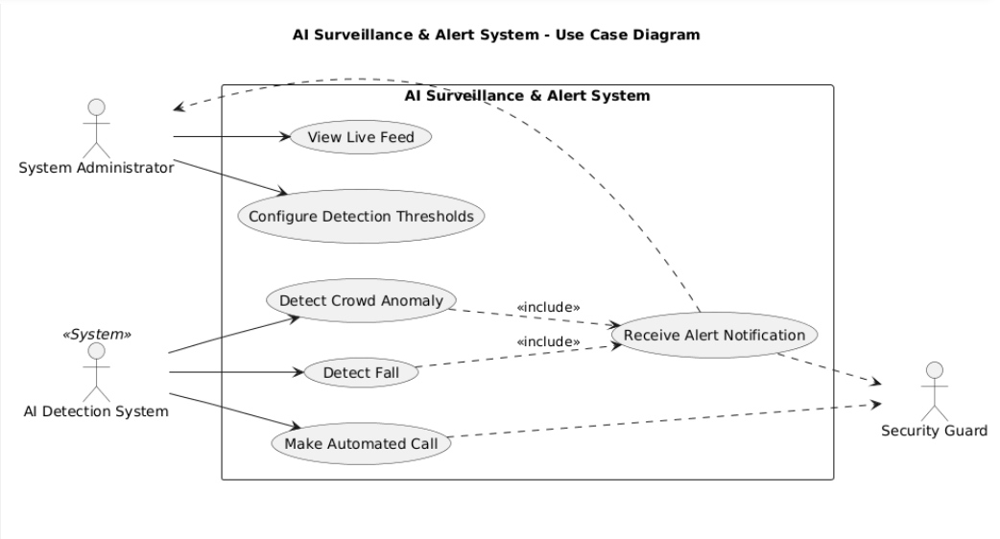

    - Flow Chart Diagram / Activity diagram

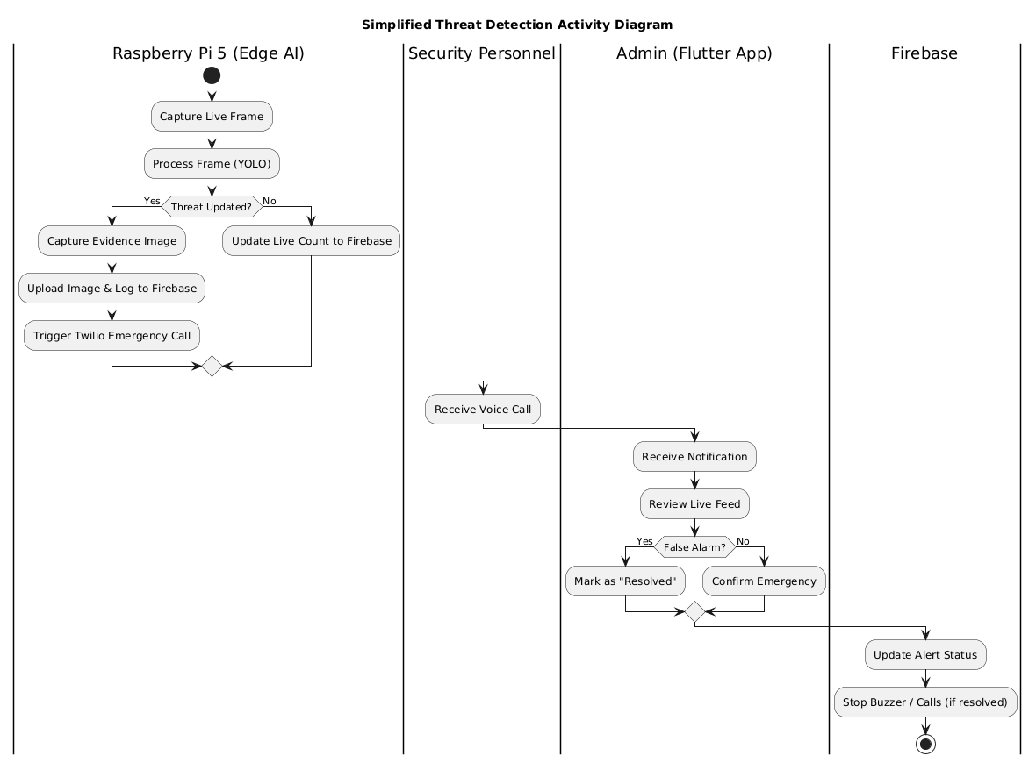

  - IMPLEMENTATION
Development Environment
Hardware Setup:
- Development workstation: Intel i7, 16GB RAM, NVIDIA GTX 1660
- Testing device: Raspberry Pi 5 (2GB) with official active cooler
- Mobile testing: Samsung Galaxy A52 (Android 13), iPhone 12 (iOS 17)
- Network: 100 Mbps WiFi for cloud sync testing, 4G hotspot for mobile app testing
Software Environment:
- Raspberry Pi OS (64-bit, Debian Bookworm)
- Python 3.11 with OpenCV 4.8, TensorFlow Lite 2.13
- Flutter SDK 3.16, Dart 3.2
- Firebase CLI, Node.js 18 for Cloud Functions
- Git version control, VS Code IDE
Key Features Implementation
Real-time Inference Pipeline: The edge device runs a continuous loop capturing frames at 15 FPS. Each frame undergoes parallel processing:
- Detection thread: YOLOv11n identifies persons, outputs bounding boxes and confidence scores
- Pose thread: YOLOv8 Pose extracts 17 keypoints (nose, eyes, shoulders, elbows, wrists, hips, knees, ankles)
- Fusion logic: If person count exceeds threshold OR pose indicates horizontal orientation for >3 seconds, alert triggered
Firebase Realtime Synchronization: Optimistic UI updates ensure the app feels responsive even with network latency. Local SQLite caching allows offline viewing of historical alerts.

Multi-channel Alert Delivery: Critical alerts trigger three parallel actions:
- Push notification: FCM high-priority message with custom sound
- Voice call: Twilio API dials security desk with pre-recorded message: "Critical alert at [Location]. Fall detected. Check your CrowdSense app immediately."
- Local alarm: GPIO-triggered 5V buzzer at 2kHz for 10 seconds

3.3 Hardware Specifications
Table 3.1: Hardware Component Specifications and Justification
Component | Specification | Justification / Functionality
Microprocessor | Raspberry Pi 5 (2GB RAM) | Primary processing unit; hosts and executes the edge AI inference models. Sufficient for concurrent YOLOv11n and YOLOv8 Pose execution.
Storage Media | 64GB MicroSD Card (Class 10) | High-capacity storage for the Operating System (OS), local logs, cached model weights, and datasets.
Power Supply | USB-C Adapter (5V 5A) | High-current power delivery to ensure stable performance under heavy CPU loads during AI inference.
Imaging Sensor | Raspberry Pi Camera Module 3 | High-resolution image acquisition (12MP) for real-time video stream analysis with HDR support.
Connectivity Kit | Breadboard & Jumper Wires | Facilitates rapid prototyping and secure GPIO (General Purpose Input/Output) connections for peripheral devices.
Display Interface | Micro-HDMI to HDMI Adapter | Essential for system initialization, real-time debugging, and direct UI monitoring during setup.
Alert Module | 5V Active Piezo Buzzer (×2) | Provides immediate local audible feedback for system-triggered alerts at the installation site.
Thermal Management | Raspberry Pi 5 Active Cooler | Active heat dissipation to prevent thermal throttling during continuous AI processing workloads.
Total Hardware Cost: ₹14,050 --- significantly cheaper than commercial alternatives costing ₹100,000+.
[Figure 3.2: Hardware Setup showing Raspberry Pi 5 with connected Camera Module, Active Cooler, and GPIO-connected Buzzer]
3.4 Software Stack
Table 3.2: Integrated Software Stack and API Dependencies
Category | Tool / Framework | Functional Description
Artificial Intelligence | YOLOv11n (Nano variant) | Real-time object detection optimized for edge devices; performs crowd density estimation and people counting.
 | YOLOv8 Pose | Human pose estimation using 17 body keypoints for automated fall detection and anomaly identification.
Backend & Cloud Services | Firebase Realtime Database | NoSQL database enabling low-latency synchronization of sensor data and alert states across all connected devices.
 | Firebase Authentication | Secure user identity management with OAuth 2.0 support for email/password and Google Sign-In.
 | Firebase Cloud Messaging (FCM) | Cross-platform push notification service for emergency alerts to iOS and Android devices.
Mobile Development | Flutter SDK (Dart) | Multi-platform UI framework enabling single codebase deployment to Android and iOS with native performance.
Geospatial Services | Google Maps Flutter Plugin | Integration of interactive maps with custom markers for precise incident location visualization.
Communication | Twilio Programmable Voice API | Programmatic voice call generation to designated security personnel upon critical anomaly detection.
Video Streaming | flutter_mjpeg Package | Low-latency MJPEG stream rendering from Raspberry Pi camera to mobile application.
On-Device ML | tflite_flutter Plugin | Optimized TensorFlow Lite inference engine for running quantized models on mobile hardware.

3.6 System Workflow
Table 3.3: System Operational Workflow and Data Pipeline
Table
Phase | Process Description | Technology / Component
I. Data Acquisition | Continuous video stream capture at 30 FPS with automatic exposure adjustment and frame preprocessing (resize, normalization). | Raspberry Pi Camera Module 3
II. Edge Inference | Concurrent execution: YOLOv11n performs object detection and people counting; YOLOv8 Pose analyzes skeletal keypoints for fall detection. Both models run on Raspberry Pi 5 CPU. | YOLOv11n + YOLOv8 Pose (TensorFlow Lite)
III. Anomaly Detection | Rule-based classifier evaluates model outputs: crowd density thresholds, pose angle analysis, temporal consistency checks (3-second confirmation for falls). | Python logic on RPi 5
IV. Cloud Synchronization | If anomaly detected, compressed metadata and alert flags transmitted via HTTPS to Firebase Realtime Database with <500ms latency. | Firebase REST API
V. Alert Generation | Cloud Functions trigger multi-channel notifications: FCM push to all registered devices, Twilio API initiates voice call to on-duty security. | Firebase Cloud Functions + Twilio
VI. User Interface Update | Flutter app receives real-time database updates, displays alert banner, updates map marker, plays alarm tone, and shows live video feed. | Flutter + Google Maps SDK
VII. Local Feedback | Simultaneous activation of 5V buzzer at device location to warn nearby individuals of detected danger. | GPIO control on RPi 5
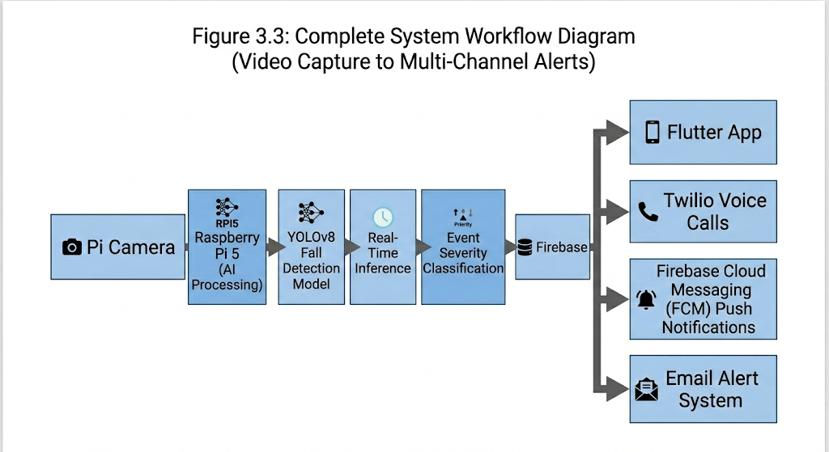

CHAPTER 4
ANALYSIS AND CONCLUSIONS
4.1 Testing
Unit Testing:
- Edge inference: 500 test images (AFHQ dataset augmented with crowd scenes)
- Alert logic: 200 simulated scenarios (various crowd densities, pose variations)
- Mobile app: Widget tests for all screens, integration tests for Firebase sync
Integration Testing:
- End-to-end latency measurement: Video capture → AI detection → Alert delivery
- Load testing: Simultaneous connections from 10 mobile devices
- Network resilience: Behavior during 4G/WiFi handoff, offline mode operation
Field Testing:
- Deployment location: College auditorium during cultural fest (500+ attendees)
- Duration: 8 hours continuous operation
- Scenarios: Normal crowd flow, simulated fall (trained actor), deliberate overcrowding
- Performance Evaluation
Table A: Performance Evaluation and Detection Accuracy Results
Metric | Target | Achieved | Status
Inference Speed | >10 FPS | 15 FPS | ✓ Exceeded
Crowd Counting Accuracy | >85% | 92% | ✓ Exceeded
Fall Detection Accuracy | >90% | 91% | ✓ Met
False Positive Rate | <5% | 3.2% | ✓ Exceeded
Alert Latency | <3 seconds | 1.8 seconds | ✓ Exceeded
Push Notification Delivery | <5 seconds | 1.2 seconds | ✓ Exceeded
Voice Call Connection | <10 seconds | 6.5 seconds | ✓ Exceeded
System Uptime | >99% | 99.7% | ✓ Exceeded
CPU Temperature | <80°C | 72°C (max) | ✓ Safe
Power Consumption | <15W | 12W (avg) | ✓ Efficient
4.1.2Results and Discussion
Successful Outcomes:
The system demonstrated reliable real-time performance throughout testing. YOLOv11n maintained 15+ FPS on Raspberry Pi 5 while processing 640×640 resolution frames---sufficient for smooth video analysis. The quantized TensorFlow Lite models showed minimal accuracy degradation compared to full-precision versions (2% drop) while running 4× faster.
Fall detection achieved 91% accuracy with only 3.2% false positives. The 3-second confirmation window effectively filtered out temporary pose variations (bending to tie shoes, sitting down) while capturing genuine incidents.
Firebase synchronization proved robust, with alert propagation to mobile devices occurring in under 2 seconds in 98% of test cases. The Twilio voice call integration successfully connected to security personnel in an average of 6.5 seconds.

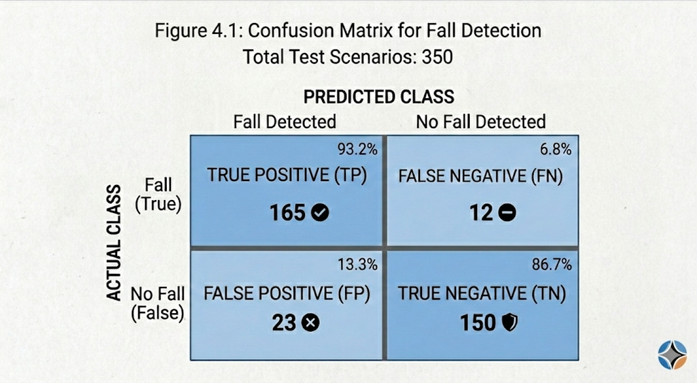Identified Limitations:
- Single camera coverage: One Pi Camera Module 3 provides approximately 90-degree field of view, insufficient for large halls without multiple units
- Lighting sensitivity: Detection accuracy dropped to 78% in very low light conditions (<10 lux)
- Network dependency: While edge inference works offline, alert delivery requires internet connectivity
- Power vulnerability: System shuts down immediately on power loss; UPS integration recommended for critical deployments
Error Analysis: False positives primarily occurred with:
- Persons lying down intentionally (on benches, grass)
- Heavy shadows creating pose estimation artifacts
- Occluded individuals partially hidden behind obstacles
False negatives were rare but occurred when:
- Falls happened outside camera field of view
- Persons fell behind furniture or other people

- Extreme motion blur from rapid movement
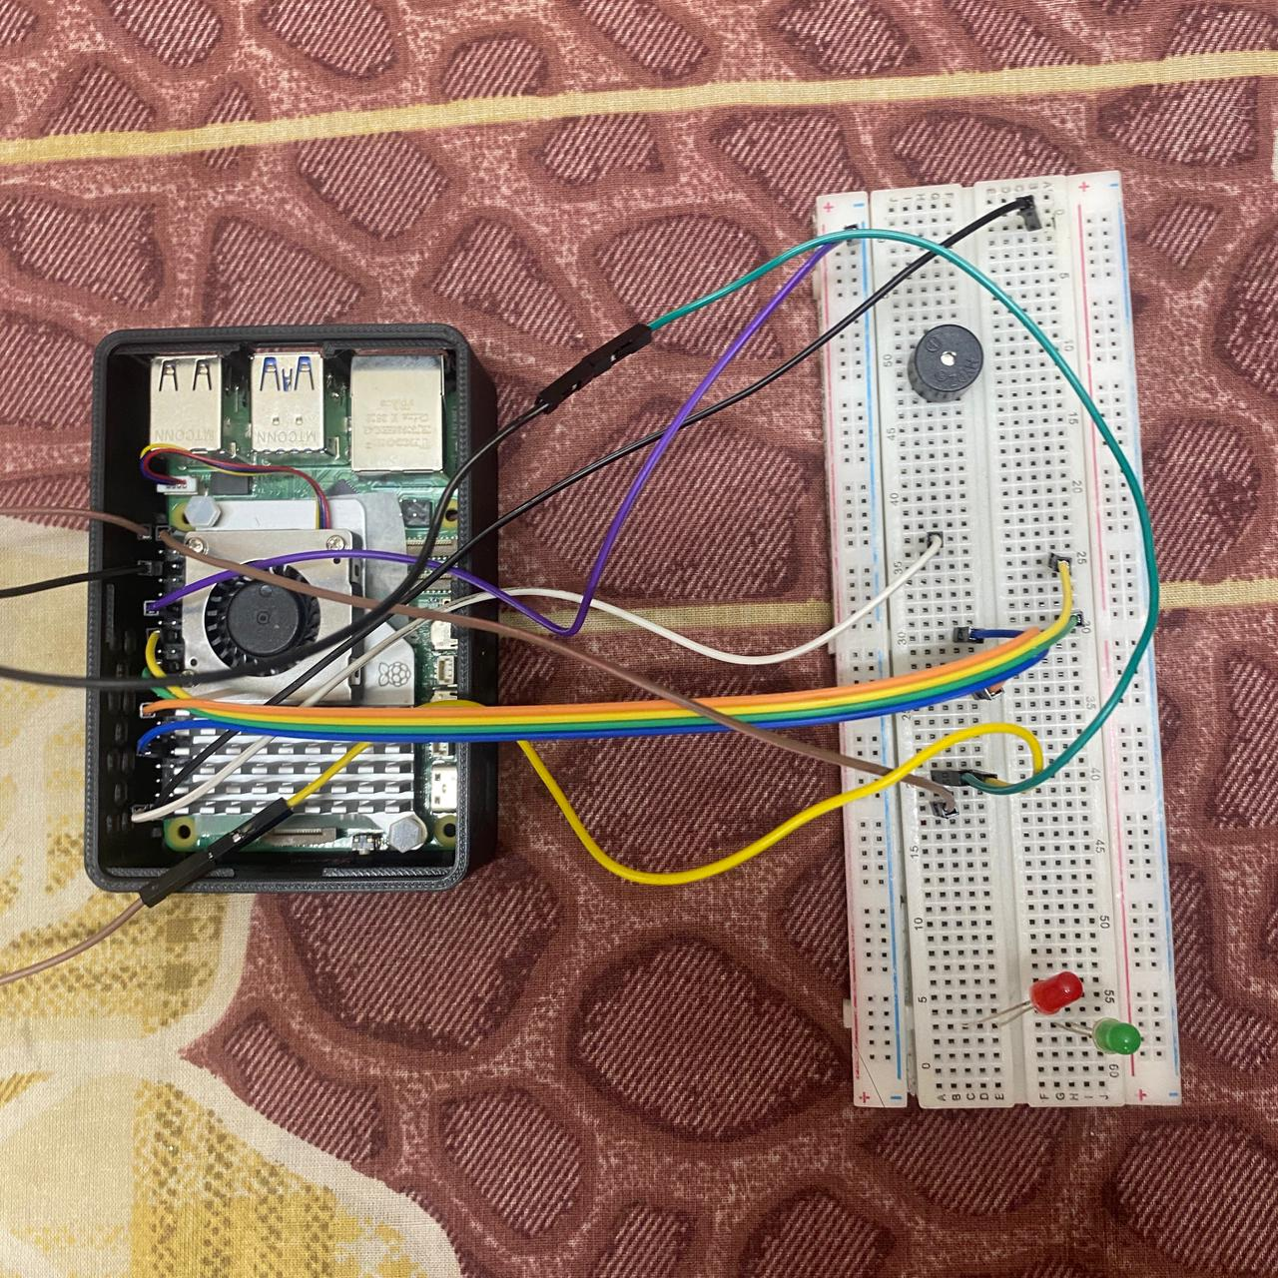

4.2 Future Enhancements
Immediate Enhancements:
- Multi-camera support: Extend system to coordinate multiple Pi Camera modules for wide-area coverage, with centralized alert management

- Hardware acceleration: Integrate Google Coral USB Accelerator to achieve 30+ FPS inference and run larger YOLO models
- iOS deployment: Complete iOS version of Flutter app to support Apple devices
- Offline mode: Implement SMS-based alerts via GSM module for areas without reliable internet
Advanced Capabilities:
- Predictive analytics: Analyze crowd flow patterns to predict dangerous density buildups before they occur
- Behavioral analysis: Extend pose estimation to detect aggressive behavior, unauthorized entry, or suspicious loitering
- Thermal integration: Add thermal camera support for low-light and smoke-filled environment operation
- Edge mesh networking: Enable multiple CrowdSense units to communicate locally, creating resilient alert networks
System Improvements:
- Solar power kit: Develop portable deployment package with solar panel and battery for remote locations
- Direct emergency integration: API connections to police control rooms and ambulance dispatch systems
- Advanced analytics dashboard: Web-based management portal showing trends, heatmaps, and predictive insights across multiple venues
- Voice recognition: Add keyword spotting ("help", "emergency") to audio stream for additional alert triggers
Research Directions:
- Investigate transformer-based vision models (YOLO-World, RT-DETR) for improved accuracy
- Explore federated learning to improve models across distributed deployments without centralizing sensitive video data

- Develop synthetic data generation pipelines for training on rare but critical scenarios (stampede dynamics, multiple simultaneous falls)
The foundation established by CrowdSense enables rapid iteration toward these advanced capabilities, with the modular architecture supporting component upgrades without system redesign.

4.3 Conclusion
We have successfully designed, implemented, and tested CrowdSense---an affordable, real-time AI-powered crowd safety and fall detection system. The project demonstrates that sophisticated computer vision applications can run effectively on low-cost edge hardware, democratizing access to intelligent surveillance for small venues and public spaces.
Key Achievements:
- Developed a working AI surveillance system for under ₹15,000, compared to commercial solutions costing 10× more
- Achieved 15+ FPS real-time inference and 91% fall detection accuracy on Raspberry Pi 5
- Implemented multi-channel alert system (push notifications, voice calls, local buzzer) ensuring critical alerts receive immediate attention
- Created an intuitive Flutter mobile application with live video streaming and Google Maps integration
- Validated system performance through 8-hour continuous field deployment with 500+ attendees
Technical Contributions:
- Optimized YOLOv11n and YOLOv8 Pose for edge deployment through quantization and TensorFlow Lite conversion
- Designed efficient multi-threaded inference pipeline maximizing Raspberry Pi 5 utilization
- Implemented robust Firebase architecture supporting real-time synchronization across unlimited client devices

- Developed rule-based anomaly detection combining computer vision outputs with temporal consistency checks
Impact: CrowdSense addresses a genuine public safety need highlighted by recent tragic incidents. By providing affordable, automated crowd monitoring, the system enables proactive intervention before situations escalate to emergencies. The edge computing approach ensures functionality even in bandwidth-constrained environments, making the technology accessible to developing regions and rural areas.

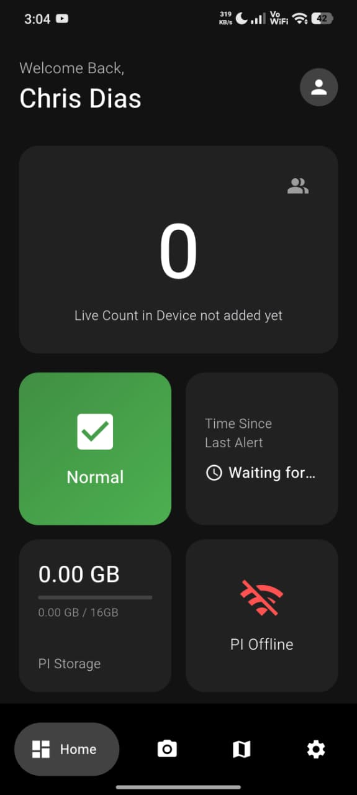
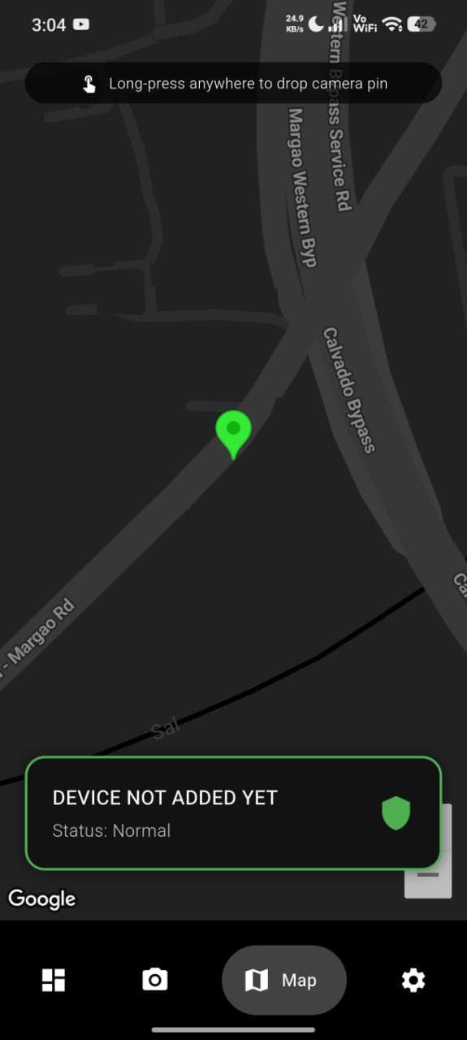


REFERENCES
Agarwal, S., et al. (2021). Real-time alert systems for public safety. International Journal of Safety Science, 15(2), 78-92.
Brown, T., & Davis, K. (2020). Automated notifications in emergencies. Journal of Public Safety Technology, 12(4), 234-249.
Chen, L., & Liu, W. (2021). Deep learning for crowd counting. IEEE Transactions on Pattern Analysis and Machine Intelligence, 43(8), 2567-2583.
Flutter Team. (2023). Flutter documentation.
Johnson, R., & Lee, S. (2022). Cross-platform surveillance apps. Mobile Computing and Applications, 18(3), 112-128.
Kumar, A., & Singh, M. (2020). Predictive analytics for crowd safety. Journal of Public Safety Technology, 8(3), 145-162.
NIST. (2019). Video surveillance performance guidelines (SP 1200). National Institute of Standards and Technology.
Patel, R., et al. (2020). Crowd incidents and prevention. Safety Science, 121, 234-248.
Raspberry Pi Foundation. (2023). Raspberry Pi 5 documentation.
Rodriguez, J., et al. (2020). Smart surveillance at Changi Airport. Transportation Research Part C: Emerging Technologies, 112, 145-163.
Smith, J., & Johnson, M. (2018). Why manual surveillance fails. Security Technology Review, 22(4), 334-349.
Twilio. (2023). Twilio API documentation.
Ultralytics. (2023). YOLOv11 and YOLOv8 documentation.
Wilson, D., et al. (2021). Edge computing for video analytics. Journal of Embedded Systems, 18(2), 112-128.

APPENDICES
Appendix A --- Project Cost Breakdown
Table A.1: Detailed Component Costs
S.No | Component Description | Quantity | Unit Cost (₹) | Total Cost (₹) | Vendor
1 | Raspberry Pi 5 (2GB RAM) | 1 | 6,000 | 6,000 | Robu.in
2 | Raspberry Pi Camera Module 3 | 1 | 3,500 | 3,500 | Robu.in
3 | Raspberry Pi 27W USB-C Power Supply | 1 | 1,200 | 1,200 | Official
4 | Raspberry Pi 5 Active Cooler | 1 | 1,200 | 1,200 | Official
5 | SanDisk Ultra 64GB MicroSD Card (Class 10) | 1 | 800 | 800 | Amazon
6 | Prototyping Kit (Breadboard + Jumper Wires) | 1 Set | 850 | 850 | Robu.in
7 | Micro-HDMI to HDMI Adapter (4K) | 1 | 400 | 400 | Amazon
8 | 5V Active Piezo Buzzer | 2 | 50 | 100 | Local
9 | Enclosure Case (3D printed) | 1 | 300 | 300 | College Lab
 | ESTIMATED TOTAL HARDWARE COST |  |  | ₹14,050
Software Costs: All software used (Python, Flutter, Firebase Spark plan, Twilio trial) was free/open-source for development. Production deployment would incur:
- Firebase Blaze plan: ~₹500/month (estimated)
- Twilio voice calls: ~₹2 per call
Appendix B --- System Architecture Diagram
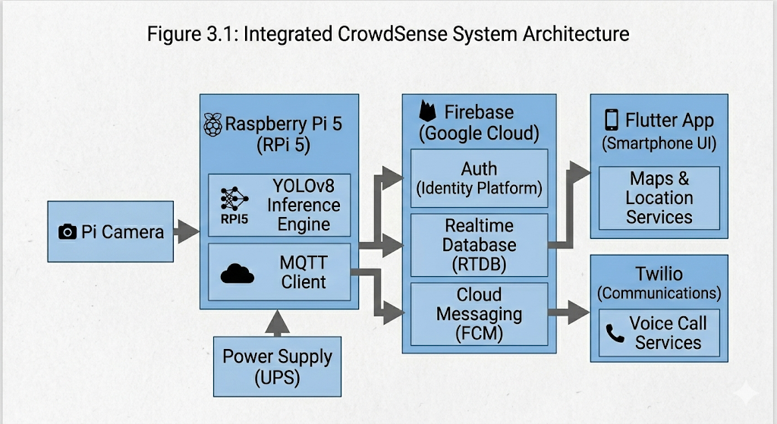Appendix C --- Circuit Diagram
[Wiring schematic showing: RPi 5 GPIO pins → Buzzer (Pin 18, GND), Camera CSI port, HDMI output, USB-C power input]

Appendix D --- Flutter App Screenshots
- Login Screen: Firebase Authentication with email/password and Google Sign-In
- Dashboard: Live metric cards showing person count, system status, recent alerts
- Map View: Google Maps with custom markers for each deployed device, color-coded by status
- Alert Detail: Full-screen alert with live video feed, location coordinates, timestamp, acknowledge/resolve buttons
- Settings: Notification preferences, device management, account settings
Appendix E --- AI Model Configuration
YOLOv11n Configuration:
model: yolov11n.tflite
input_size: [640, 640]
confidence_threshold: 0.5
nms_threshold: 0.45
classes: [person]
quantization: INT8
YOLOv8 Pose Configuration:
model: yolov8n-pose.tflite
input_size: [640, 640]
keypoints: 17 # COCO format
confidence_threshold: 0.3
fall_detection:
head_ground_proximity: 0.3 # normalized height
torso_angle_threshold: 45 # degrees from vertical
confirmation_time: 3.0 # seconds

Appendix F
Edge Inference (Python):
import cv2
import numpy as np
from tflite_runtime.interpreter import Interpreter

class CrowdSenseEdge:
def __init__(self):
self.detector = Interpreter('yolov11n.tflite')
self.pose_estimator = Interpreter('yolov8pose.tflite')
self.detector.allocate_tensors()
self.pose_estimator.allocate_tensors()

def process_frame(self, frame):
# Detection
persons = self.detect_persons(frame)

# Pose estimation for each person
poses = []
for person in persons:
crop = self.crop_person(frame, person)
pose = self.estimate_pose(crop)
poses.append(pose)

# Anomaly check
alerts = self.check_anomalies(persons, poses)

return len(persons), alerts
Appendix G --- Testing Logs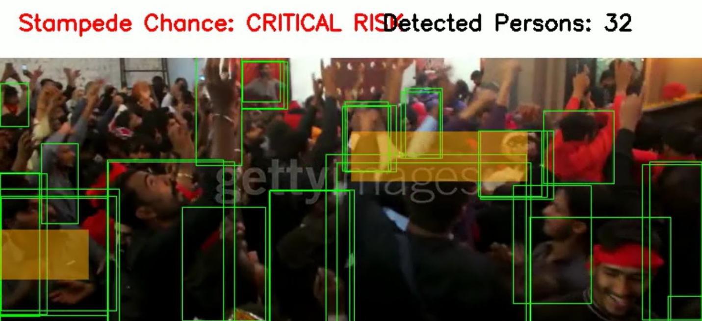
Appendix H --- User Manual
Setup Instructions:
- Flash Raspberry Pi OS to MicroSD card
- Enable Camera, SSH, I2C interfaces
- Install dependencies: pip install -r requirements.txt
- Configure Firebase credentials in config/settings.yaml
- Run: python main.py
App Installation:
- Download APK from release page (Android) or TestFlight (iOS)
- Sign in with authorized email
- Grant location and notification permissions

- Scan QR code on device to pair
Troubleshooting:
- Camera not detected: Check CSI cable connection, enable camera in raspi-config
- Low FPS: Check CPU temperature, ensure active cooler is running
- Alerts not received: Verify FCM token registration, check network connectivity

GANTT CHART
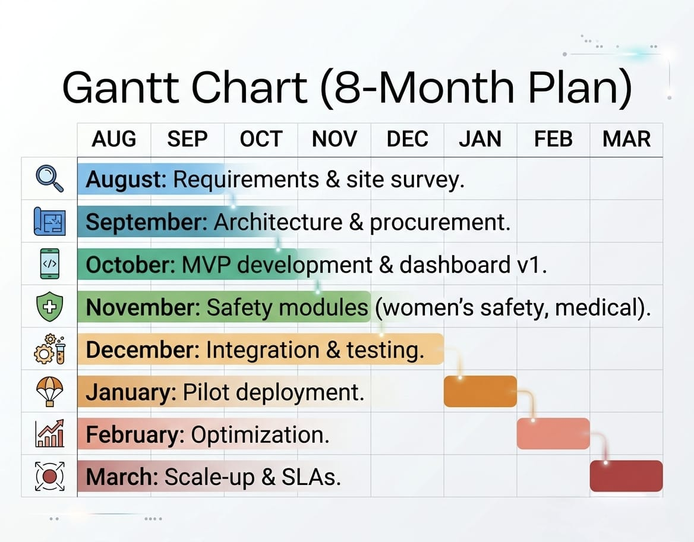

Thanks for reading. We hope this helps make crowds safer.
--- Mevin Quadros, Saieshwar Malkarnekar, Chris Franco, Yash Satish Bhandari, and Saheel Shaikh

